**Question 1:** **[5 Points]**

**Question 2:** Propose a Workflow mechanism--------------------------------------------------------------------------------------------------------------------------------------------------------------------------------------------------------------------------------------------------------------------------------------------------------------------------------------------------

**[5 Points]**

**Sample Answer :**

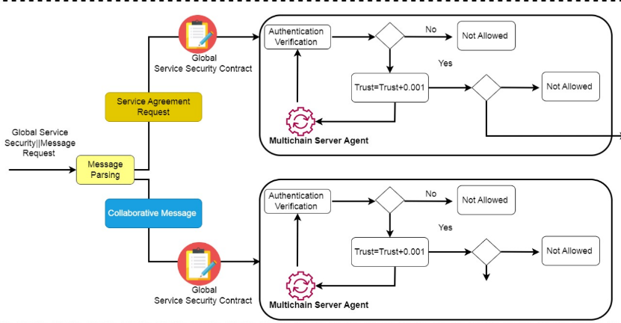

**Note “Your Solution Highlights the Workflow of particular smart contract ”**

**Question 3: Usecase** : In--------------------. How can the integration of------------------------? Additionally, identify at least three security challenges associated with this use case from a security standpoint and provide corresponding security solutions using blockchain technology, including -------------------------------------------------------------------------------------------------------------

**Sample Answer**

Required System Diagram {Illustrate the system model with explanation of each modules in the particular usecase}

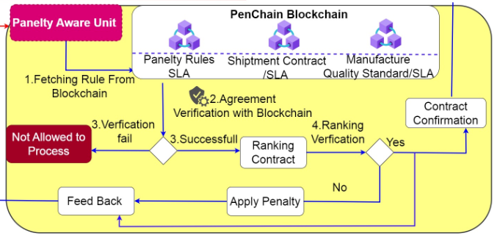

**[5 Points]**

**Question 4 : Statement**: “------------------------------------”. Write ----reason with justification --------------------------------------------------------------------------------

Sample Answer {Justification Required}

**[5 Points]**

**Question 5 :** Write a pseudocode-based smart contract ----------------------------------------------------

**contract SampleContract {**

**// Declare state variables**

**address public owner;**

**uint public value;**

**// Constructor function**

**constructor() {**

**owner = msg.sender;**

**}**

**// Modifier to restrict access to the owner**

**modifier onlyOwner() {**

**require(msg.sender == owner, "Only the owner can access this function.");**

**_;**

**}**

**Question 6:** **[5 Points]**

**Question 7:** **[5 Points]**

**Question 8:** **[5 Points]**

**Question 9:** **[5 Points]**

**Question 10:** **[5 Points]**

**Question 11:** **[5 Points]**

**Question 12:** **[5 Points]**

**[5 Points]**